1. Create a function module to import a range of customer numbers and export the customer data for the given range.

Customer Data can be found in table KNA1.

Time : 30 minutes

Create a package and keep all objects created for this task in that package.

Paste screenshots of all the objects created for this task.

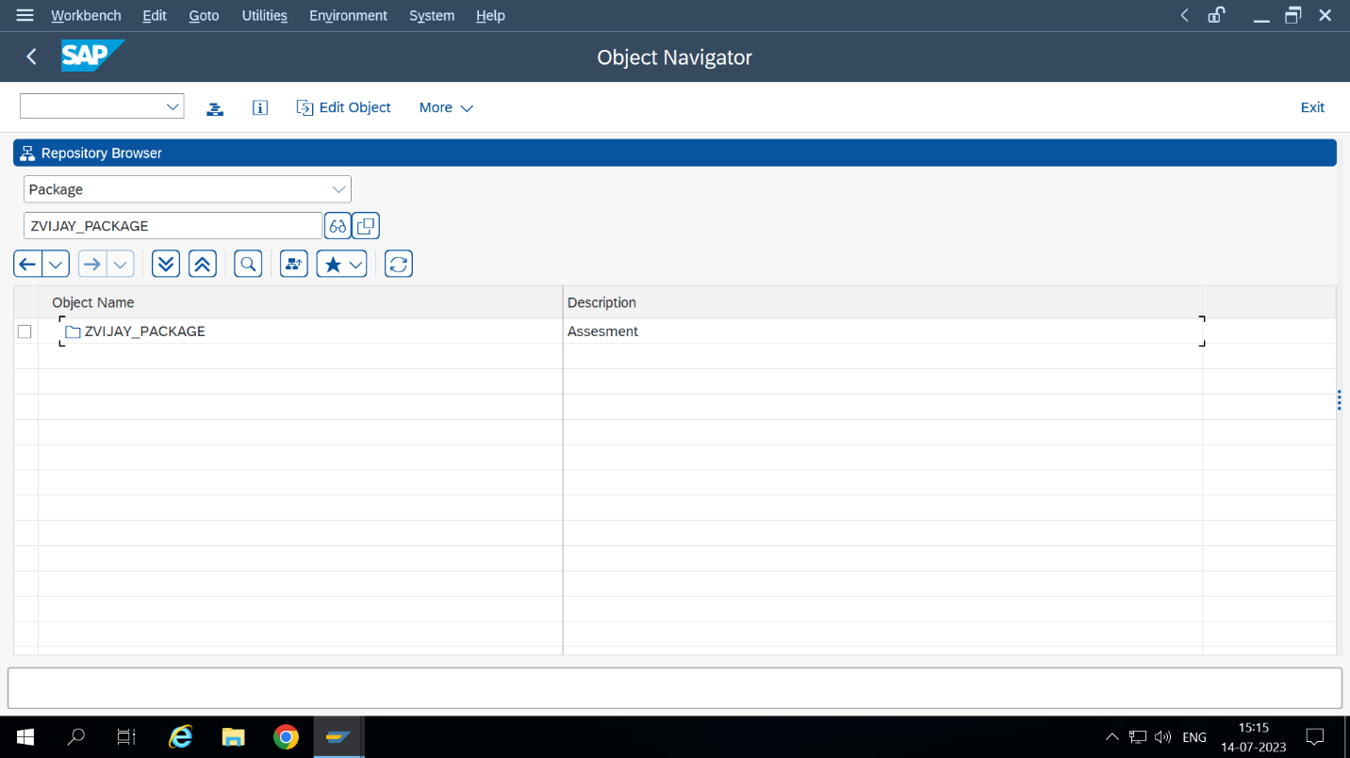Package Creation:

Created A RANGE TABLE OF Customer.

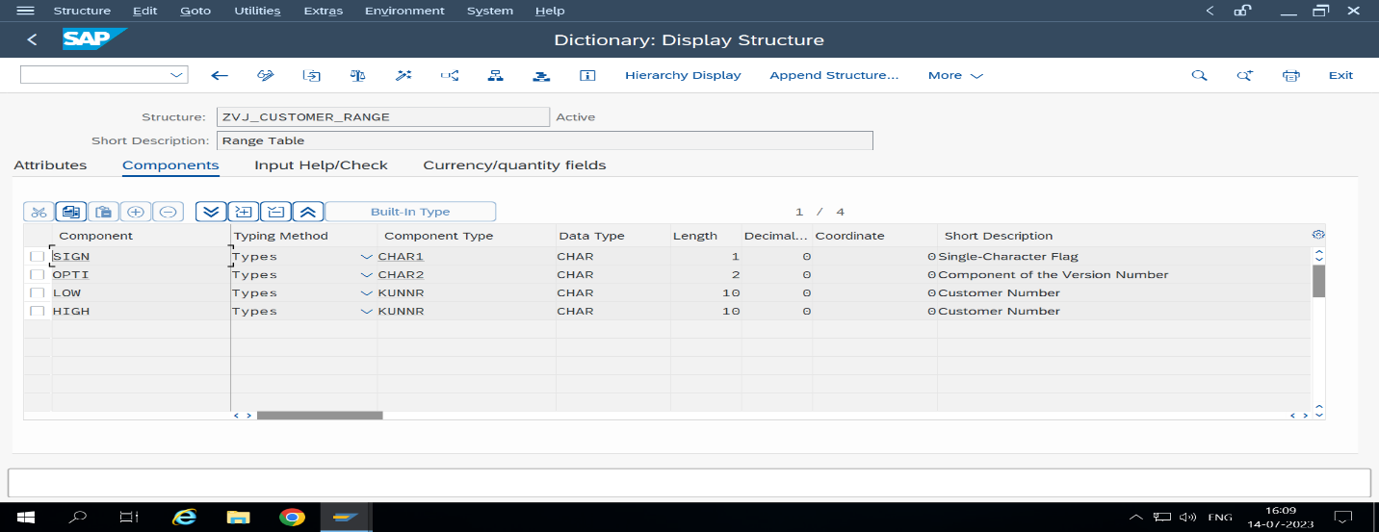

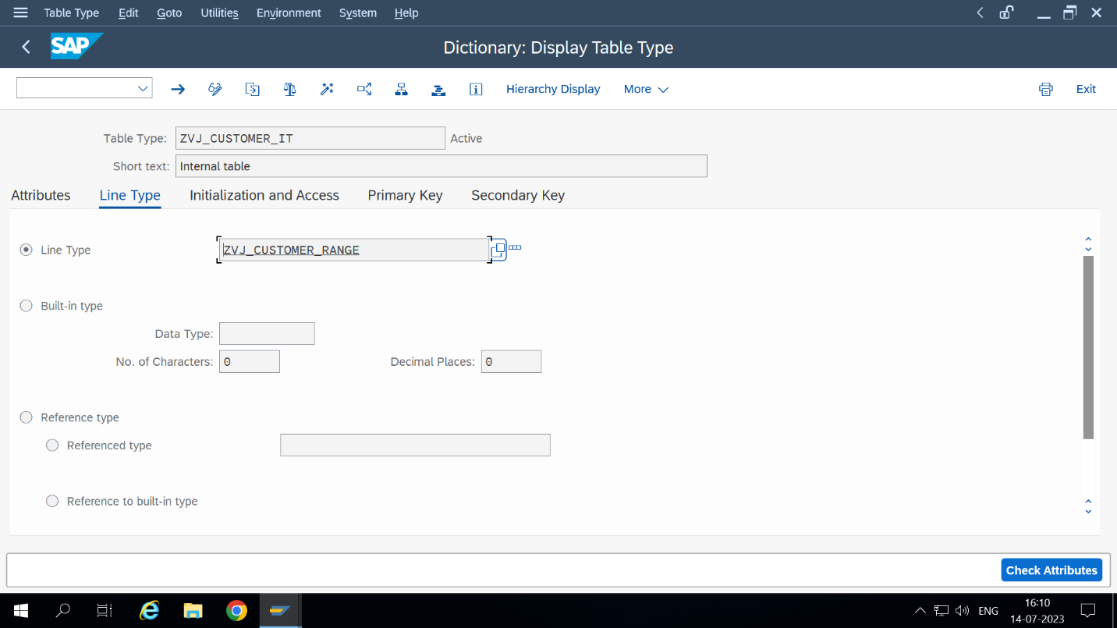

NEXT STEP : Created one function Madule Inside Function Group **ZVJ_FG .**

**Craeted One Fucntion Module Name Called ZVIJAY_CUSTOMER.**

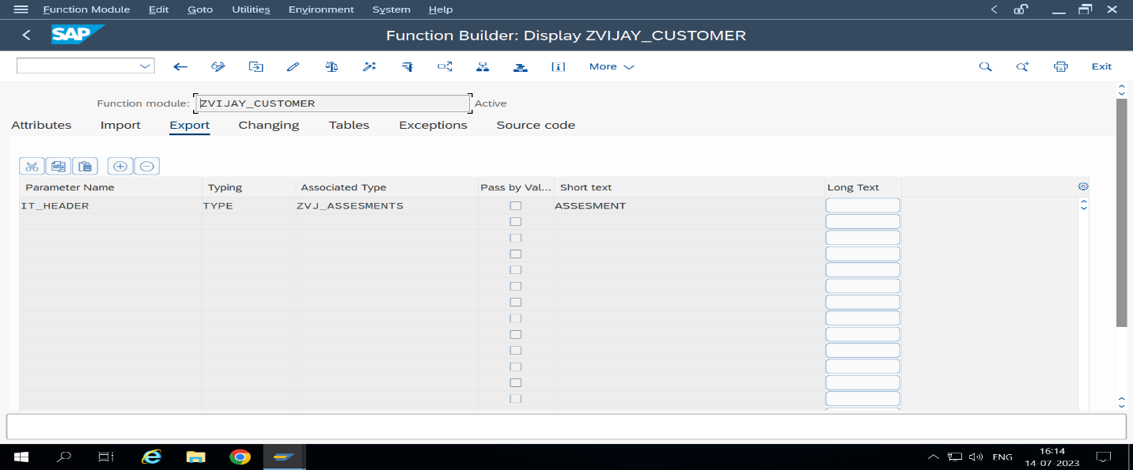

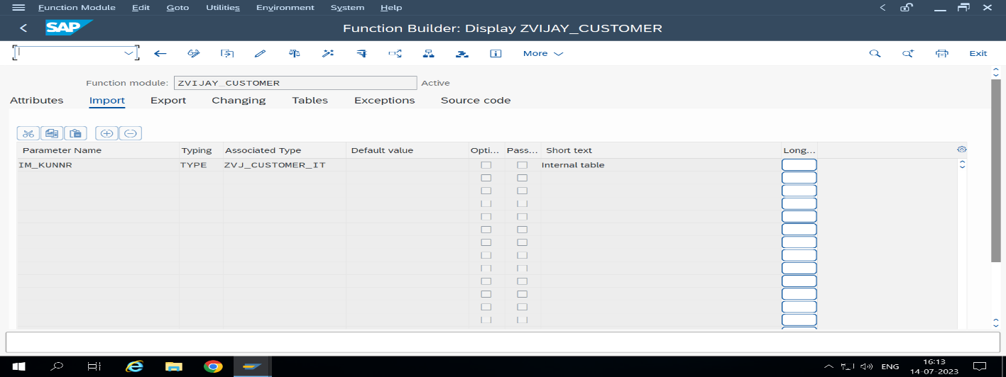

Function Module code

FUNCTION ZVIJAY_CUSTOMER.  
*\*"----------------------------------------------------------------------*  
*\*"*"Local Interface:*  
*\*" IMPORTING*  
*\*" REFERENCE(IM_KUNNR) TYPE ZVJ_CUSTOMER_IT*  
*\*" EXPORTING*  
*\*" REFERENCE(IT_HEADER) TYPE ZVJ_ASSESMENTS*  
*\*"----------------------------------------------------------------------*  
  
  
SELECT kunnr land1 name1 from kna1 Into TABLE IT_HEADER where kunnr in im_kunnr.  
  
  
  
  
  
ENDFUNCTION.

CREATED MAIN PROGRAM TO READ THE DATA AND DISPLAY CUSTOMER DETAILS WITH CUSTOMER RANGE.

*\*&---------------------------------------------------------------------\**  
*\*& Report ZVIJAY_ASSESMENTS*  
*\*&---------------------------------------------------------------------\**  
*\*&*  
*\*&---------------------------------------------------------------------\**  
REPORT ZVIJAY_ASSESMENTS.  
  
data v_kunnr TYPE kunnr.  
  
DATA it_data TYPE ZVJ_ASSESMENTS.  
DATA wa_data LIKE LINE OF it_data.  
  
SELECT-OPTIONS s_kunnr for v_kunnr.  
START-OF-SELECTION.  
PERFORM getdata.

END-OF-SELECTION.  
PERFORM display.  
  
  
*\*&---------------------------------------------------------------------\**  
*\*& Form getdata*  
*\*&---------------------------------------------------------------------\**  
*\*& text*  
*\*&---------------------------------------------------------------------\**  
*\*& --> p1 text*  
*\*& <-- p2 text*  
*\*&---------------------------------------------------------------------\**  
FORM getdata .  
  
CALL FUNCTION 'ZVIJAY_CUSTOMER'  
 EXPORTING  
 im_kunnr = s_kunnr[]  
 IMPORTING  
 IT_HEADER = it_data  
 .  
ENDFORM.  
*\*&---------------------------------------------------------------------\**  
*\*& Form display*  
*\*&---------------------------------------------------------------------\**  
*\*& text*  
*\*&---------------------------------------------------------------------\**  
*\*& --> p1 text*  
*\*& <-- p2 text*  
*\*&---------------------------------------------------------------------\**  
FORM display .  
WRITE : / 'customer number ',  
 20 'Country',  
 40 'name1'.  
  
loop at it_data into wa_data.  
 WRITE : / wa_data-kunnr,  
 20 wa_data-land1 ,  
 40 wa_data-name1 LEFT-JUSTIFIED.  
 ENDLOOP.  
ENDFORM.

**OUTPUT**

